DEVOPS GIT BASICS PROJECT REPORT

Submitted By:
Name: Shariqua Patel Farooque
Course: DevOps
Project Title: Git Basics – Repository Creation and Version Control
Date: 20-02-2026

1. Introduction
This project demonstrates the implementation of basic Git and GitHub operations. It includes initializing a local repository, creating and tracking files, committing changes, connecting to a remote GitHub repository, and managing version updates.
The purpose of this project is to understand version control workflows used in DevOps practices.

2. Project Objective
The objectives of this project are:
To create a public GitHub repository.
To initialize a local Git repository.
To create and track project files.
To commit changes using Git.
To connect a local repository to GitHub.
To push code to a remote repository.
To update project version and maintain version control.

3. Repository Creation on GitHub
A public GitHub repository named:
devops-git-basics
was created without initializing it with README, .gitignore, or license files.

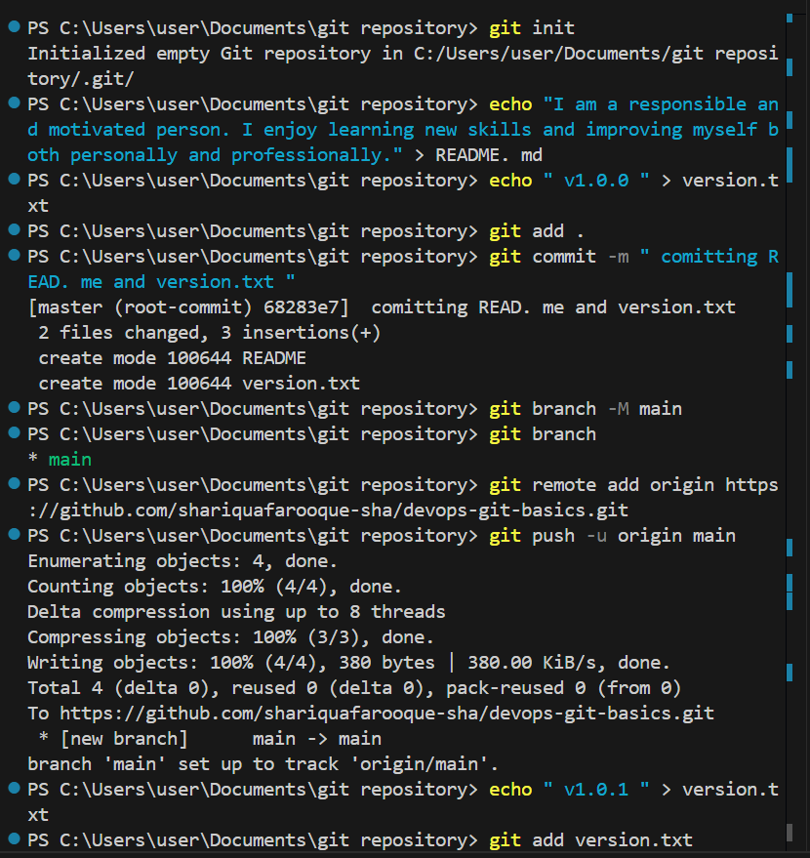

4. Local Repository Setup

4.1 Initialize Git Repository
Command Used:
git init
Output:
Initialized empty Git repository in C:/Users/user/Documents/git repository/.git/
Explanation:
The git init command creates a hidden .git folder which enables Git to track changes in the project directory.

5. File Creation

5.1 Creating README.md
Command Used:
echo "I am a responsible and motivated person. I enjoy learning new skills and improving myself both personally and professionally." > README.md
Purpose:
The README.md file contains a short personal bio and describes the repository.

5.2 Creating version.txt
Command Used:
echo "v1.0.0" > version.txt
Initial Version:
v1.0.0
The version.txt file is used to maintain project version information.

6. Staging and First Commit

6.1 Adding Files to Staging Area
Command:
git add .

6.2 Committing Files
Command:
git commit -m "committing README and version.txt"
Output:
[master (root-commit) 68283e7] committing README and version.txt
2 files changed, 3 insertions(+)
create mode 100644 README.md
create mode 100644 version.txt
Explanation:
This was the first commit (root commit). Both files were successfully added to version control.

7. Renaming Branch to Main
Command:
git branch -M main
Verification:
git branch
Output:
main
Explanation:
The branch was renamed to "main" because GitHub uses main as the default branch.

8. Connecting to Remote Repository
Command:
git remote add origin https://github.com/shariquafaroque-sha/devops-git-basics.git
Explanation:
The local repository was connected to the remote GitHub repository using the remote name "origin".

9. First Push to GitHub
Command:
git push -u origin main
Output:
Enumerating objects: 4, done.
Counting objects: 100% (4/4), done.
Writing objects: 100% (4/4), done.
[new branch] main -> main
branch 'main' set up to track 'origin/main'.
Explanation:
The local repository was successfully pushed to GitHub. The -u option set upstream tracking.

Updating Project Version
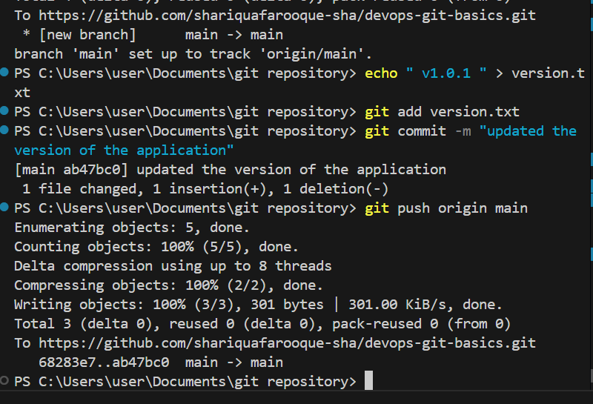

10.1 Updating version.txt
Command:
echo "v1.0.1" > version.txt
Old Version:
v1.0.0
New Version:
v1.0.1

10.2 Staging the Updated File
Command:
git add version.txt

10.3 Committing the Update
Command:
git commit -m "updated the version of the application"
Output:
[main ab47bc0] updated the version of the application
1 file changed, 1 insertion(+), 1 deletion(-)
Explanation:
The old version line was replaced with the new version.

10.4 Pushing Updated Version
Command:
git push origin main
Output:
Enumerating objects: 5, done.
Writing objects: 100% (3/3), done.
main -> main
Explanation:
The updated version was successfully pushed to GitHub.

11. Final Repository Link
https://github.com/shariquafaroque-sha/devops-git-basics

12. Conclusion
This project successfully demonstrated the practical use of Git and GitHub in a DevOps workflow. The tasks completed include:
Repository initialization
File tracking
Making commits
Branch management
Remote repository connection
Version updating
Pushing changes to GitHub
The project provided hands-on experience with essential Git commands used in real-world DevOps environments.

